Regex code

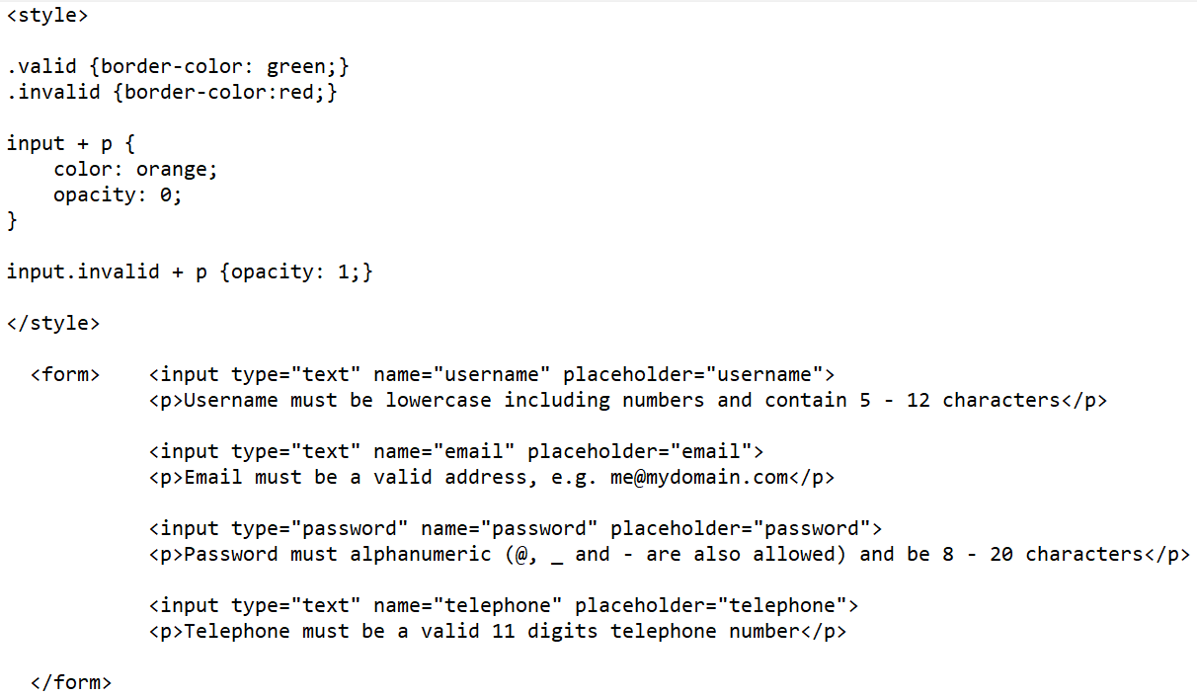

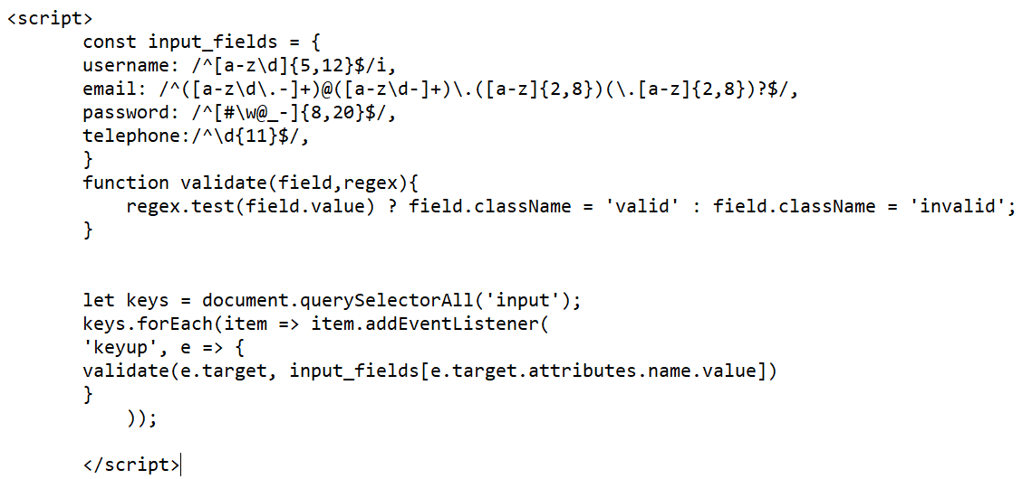

**REGEX METHODS :**

1. **TEST METHOD :**

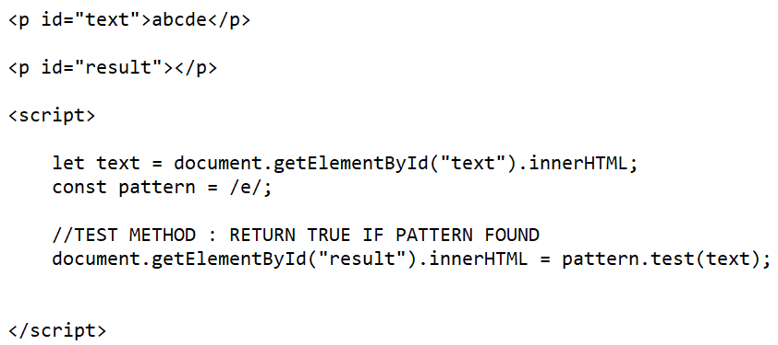

1. **EXEC METHOD**

.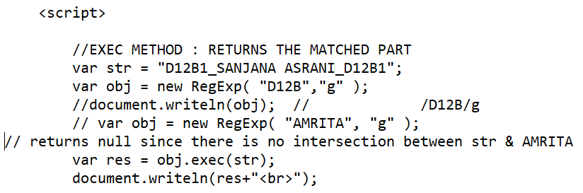

1. **SEARCH METHOD**

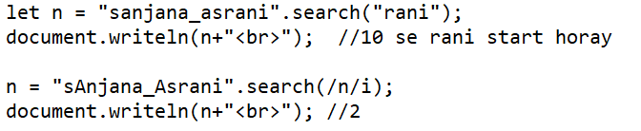

1. **REPLACE METHOD**

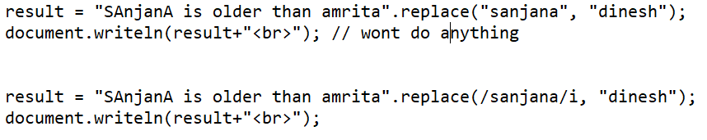

***JQUERY :***

***Box hide show toggle :***

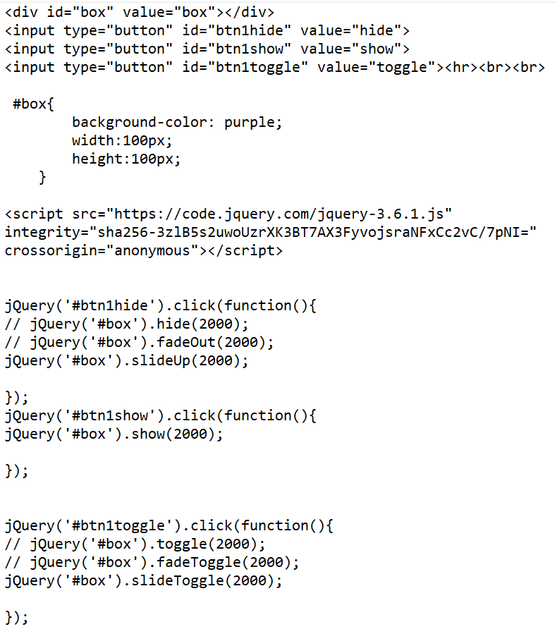

**Bulb on & off**

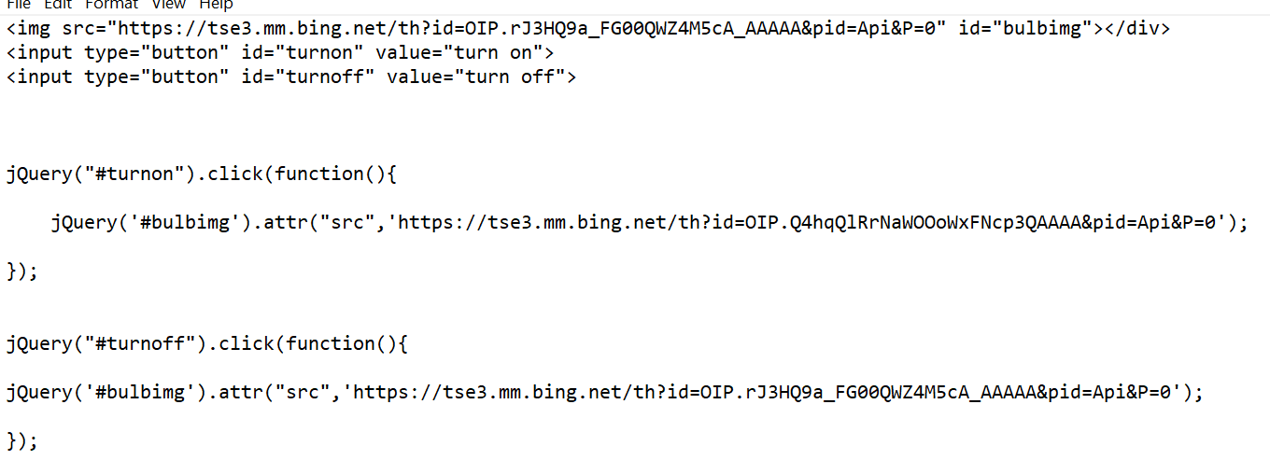

**Append & Prepend**

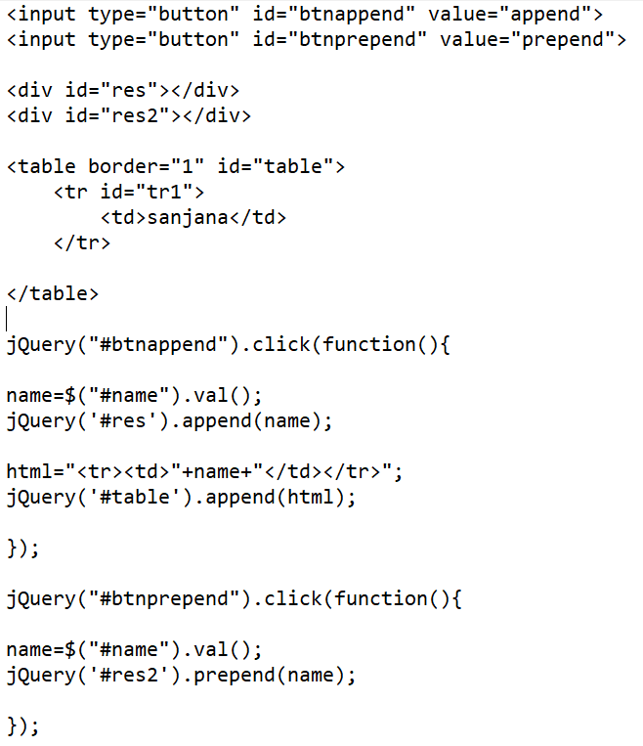

**Get CSS properties :**

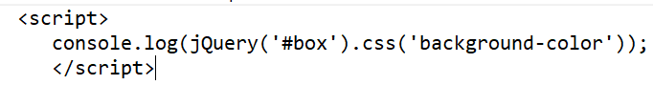

**Set CSS properties :**

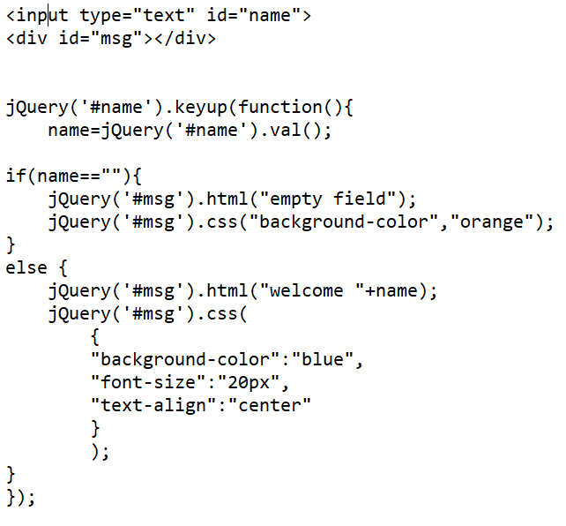

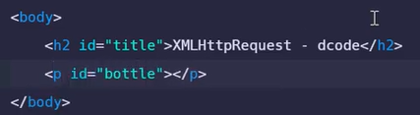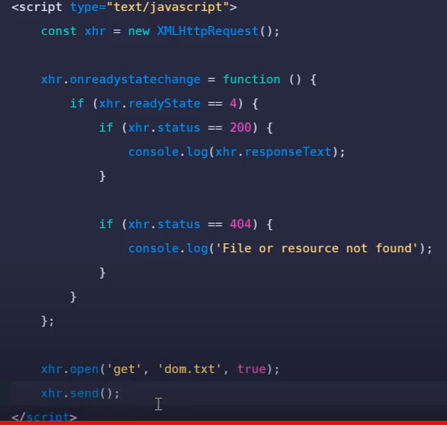





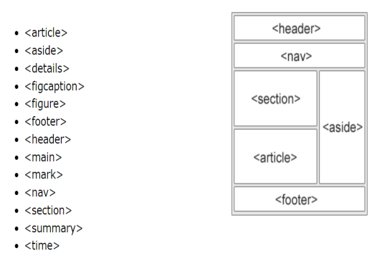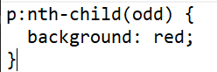

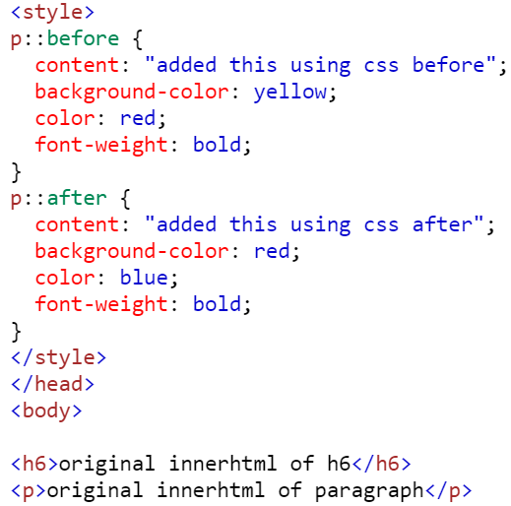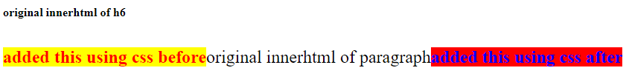

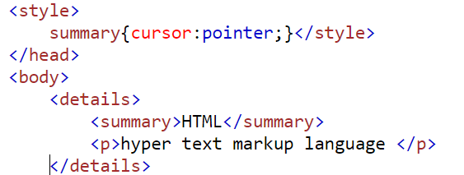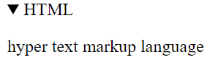

background:url('img1.jpg') no-repeat;

background-size: cover;

<table cellspacing="0" border="1" width="100%" height="30%">

<caption>Timetable D12B</caption>

<tr>

<th> MON </th>

<th> TUES </th>

<th> WED </th>

<th> THURS</th>

<th> FRI </th>

</tr>

<tr>

<td>SE(PJO)</td>

<td rowspan="2">

<pre>

DWM/A

CN/B

SE/C

</pre>

</td>

<td>DWM(PRL)</td>

<td>SE(PJO)</td>

<td>CN(PAG)</td>

</tr>

<tr>

<td>IP(PLS)</td>

<td>IP(PLS)</td>

<td>IP(PLS)</td>

<td>SE(PJO)</td>

</tr>

<tr>

<td>TCS(SSU)</td>

<td>TCS(SSU)</td>

<td rowspan="2">

<pre>

SE/A

DWM/B

CN/C

</pre>

</td>

<td>BCE(POK)</td>

<td rowspan="2">BCE B1</td>

</tr>

<tr>

<td>DWM(PRL)</td>

<td>BCE(POK)</td>

<td>CN(PAG</td>

</tr>

<tr>

<td rowspan="2">

<pre>

B1: MINIPROJECT

B2: BCE LAB

</pre>

</td>

<td>CN(PAG)</td>

<td rowspan="2">

<pre>

CN/A

SE/B

DWM/C

</pre>

</td>

<td>TCS(SSU)</td>

<td rowspan="2">MINIPROJECT</td>

</tr>

<tr>

<td>DWM(PRL)</td>

<td>SEL</td>

</tr>

</table>

